Colorado School to Create Newest 'Body Farm'

By CHRISTINA NG (@ChristinaNg27)
Nov. 29, 2012
Colorado Mesa University is using its high altitude and arid setting to create what will soon be the country's newest body farm.
The "farm" will join five others around the country, facilities that have become vital, although macabre, forensic laboratories.
The oldest of these is located deep in the hills near Knoxville, Tenn., where over 150 bodies can be found in various states of decomposition at any given time. The bodies can be partially buried, under tarps, in the trunks of cars or hanging from nooses.
The one-acre area isn't a crime scene. It's an outdoor forensic laboratory, sometimes referred to as a body farm.
This particular lab is the University of Tennessee's Forensic Anthropology Center. It is the country's first and largest--in terms of the number of bodies--outdoor forensic research facility, one of only a handful in the world.
"We don't alter the vegetation, we don't alter the soil, we don't alter the plants or animals. It really is a natural laboratory," the University of Tennessee's Forensic Anthropology Center director Dr. Dawnie Steadman told ABCNews.com. "If you're going to be answering police questions about decomposition, then you really need to use humans."
The grounds are highly secure and not open to the public. The land is surrounded by a wooden fence and another metal fence topped with razor wire.
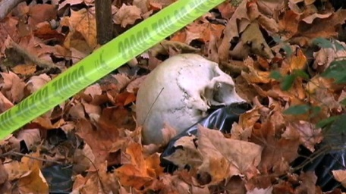
University of Tennessee's Forensic Anthropology Center
The University of Tennessee's Forensic... View Full Size

Researchers, students, coroners and law enforcement officials are among those who are granted access to the facility for learning purposes.
"The main research is on decomposition, what happens to the body in different climates, in different positions, in different states, whether they're covered or uncovered, buried or unburied," Steadman said.
"Many of the questions that are asked come from real police cases," she said. "We can actually try to mimic that scientifically and observe what happened."
Over 1,000 bodies have been donated since the facility opened in 1981 and the bodies and skeletons are used for years after the donation. Knowing the donors' history and background allows researchers to work to determine the body's age, gender, stature and ancestry, and then check their findings with the provided history.
Steadman said the facility is extremely grateful to the donors that donate their bodies specifically to the lab.
"There really is no limit to how the donated bodies can contribute to science," she said. "We're really blessed with the generosity of our donors."
A similar facility will soon be opening near Grand Junction, Colo. It will be the first high-altitude outdoor lab and the sixth outdoor forensic laboratory in the country.
"The Rocky Mountains is not the same as Tennessee, it's not the same as Texas and when a body is dumped outside it decays differently," Dr. Melissa Connor, director of Colorado Mesa University's Forensic Investigation Research Station, told ABCNews.com.
"We've got the altitude, which impacts the humidity, it impacts the infestation, the amount of sunshine as well as temperature," she said. "It will teach us more about what happens in this environment, which we can extrapolate more to the western United States."
The Colorado laboratory is being built in a dry dessert setting, vastly different from Tennessee's dense woods. The labs look forward to collaborating and sharing research in the future.
"You can't simulate this [research] in a lab," Connor said. "The educational component in invaluable."

/jo

