Are ‘Smart Guns’ for Law Enforcement in Obama’s Sights?
Wed, 01/06/2016 - Sean Allocca, Editor

http://www.forensicmag.com/topics/digital-forensics

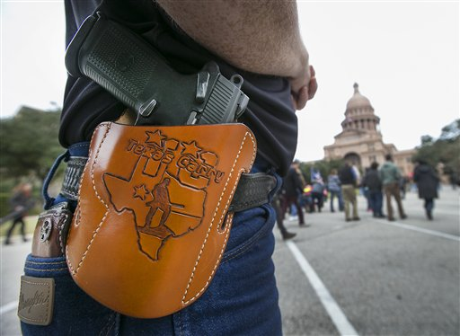

In a Friday, Jan. 1, 2016 photo, Terry Holcomb, Executive Director of Texas Carry happily displays his customized holster as he walks to the Capitol for a rally. Open Carry Texas and Texas Carry held a rally on the south steps of the Texas State Capitol in Austin to celebrate Texas becoming an open carry state. President Barack Obama defended his administration's plans to tighten the nation's gun-control restrictions without going through Congress, insisting Jan. 4 that the steps he'll announce fall within his legal authority and uphold the constitutional right to own a gun. (Ralph Barrera/Austin American-Statesman statesman.com via AP)Along with President Obama’s executive action on gun control, the White House is trying to control its own firearms by looking into new smart-gun technology.
In a statement issued Wednesday, the White House directed the departments of Justice, Defense, and Homeland Security to examine ways to implement guns that use biometrics—a person’s unique biological characteristics, like fingerprints—to make sure only the gun’s owner can fire the weapon.
Smart guns aren’t new, but now there are dozens of start-up companies, with a handful of different systems, trying to break into the marketplace. Radio Frequency Identification (RDIF) systems are used on some guns that can only be authenticated when in close proximity to a token, like a ring or a wristwatch, worn by the user. Others systems use fingerprint sensors to unlock the safety.
In the Memorandum, President Obama gave the agencies 90 days to prepare a report outlining a strategy to “expedite real-world deployment.”
Advocates say these new technologies could be life-saving in situations where guns are taken from police officers in violent struggles. Or, in instances where guns are stolen from law enforcement: for example, the fatal shooting of 32-year-old Kate Steinle, in San Francisco, last July, when a gun stolen from a Bureau of Land Management officer just days earlier was accidently discharged on a busy tourist pier.
However, the technologies are not yet fool proof, and critics say they might be too cumbersome and unreliable in life-and-death situations. Unlike other biometrics systems—like the fingerprint scanner used to unlock your iPhone—these biometrics need to work the first time, every time.
In an emotional press conference on Tuesday, Obama reiterated the necessity for such smart weapons: “If we can set it up so you can't unlock your phone unless you've got the right fingerprint, why can't we do the same thing for our guns? If there's an app that can help us find a missing tablet ... there's no reason we can't do it with a stolen gun.”
The NRA says it does not oppose the development of smart guns, nor for Americas to “voluntarily acquire them," however the association believes no viable gun currently exists.
Obviously the issue has and will be hotly debated. Obama has openly blamed the gun lobbyists for blocking gun-control proposals in the past, while organizations, like the NRA, say Obama is trying to strip citizens of their second amendment right, and blame guns for his failed policies

